User Guide

I. Pre-Flight Checklist
A. Make sure you are using Blender version 3.6 LTS
B. Setup Blender for metric measurements and precision modeling:
1. Video guide can be found here https://youtu.be/R-Vq2O-hvfo
2. After following the steps in the above video tutorial, it’s best practice to delete the default Camera, Cube, and Light from the scene.
a. They will not be used and will only get in the way
b. Right click each item in the SCENE COLLECTION are and select DELETE
c. Your default setup should look something like this:
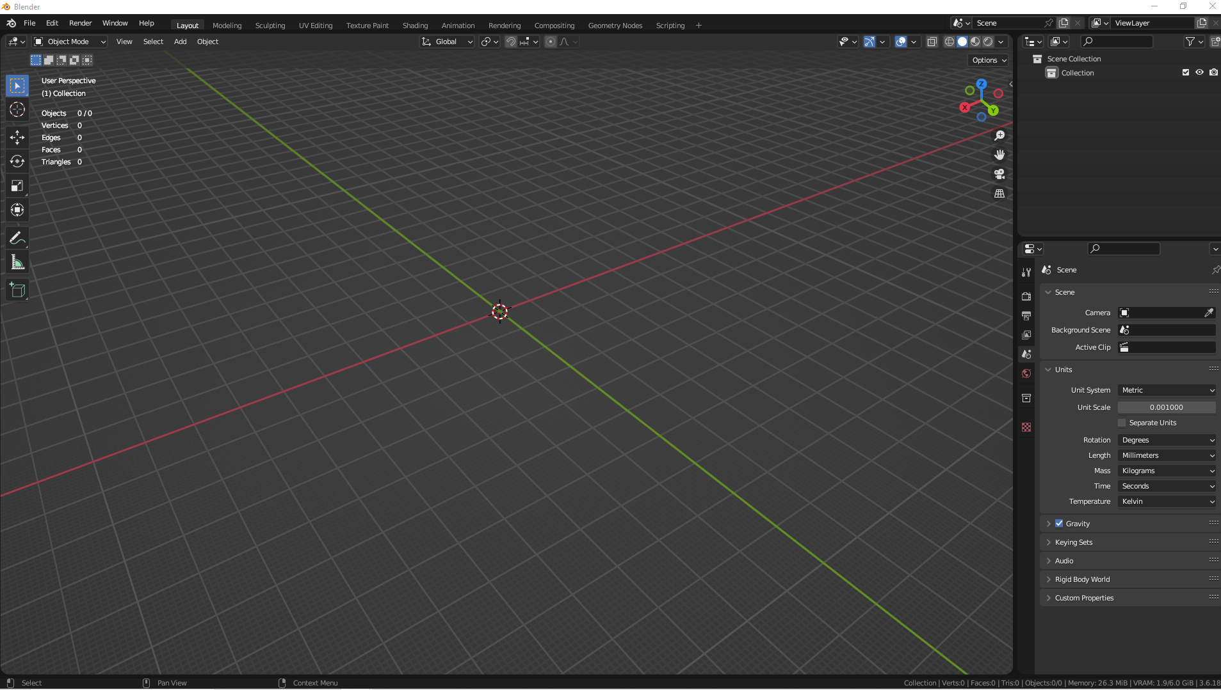

C. Add-on Installation (WINDOWS 10)
1. When downloading from Github the file will automatically be archived in .zip format
a. Extract the “assets.blend” and “helmet_V14.py” files into a new folder, named so that you can remember it and locate it.
b. Find the folder and open it, highlighting both “assets.blend” and “helmet_V14.py”, right click
and select SEND TO > COMPRESSED (ZIPPED) FOLDER
2. In Blender, click EDIT > PREFERENCES > ADD-ONS and select INSTALL
a. Guide detailing this process can be found at https://youtu.be/B4gbMpTcpJQ
b. Locate the folder with the newly-created ZIP file and select it
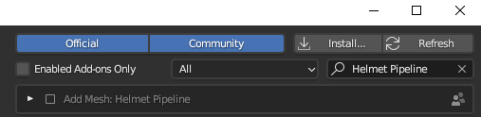
c. You will see this, check the ADD MESH box and then save your preferences:

II. Blender Manipulation of Scan Data
A. Make sure the side-bar is visible, either by pressing N or clicking the tiny left-facing arrow:
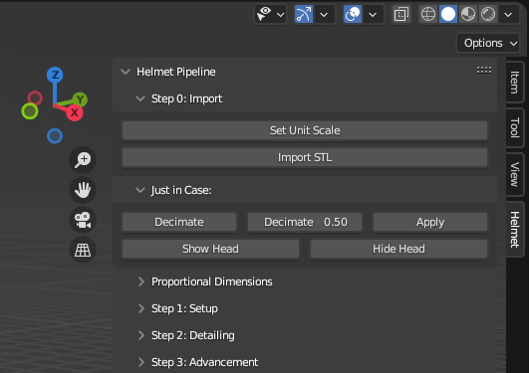
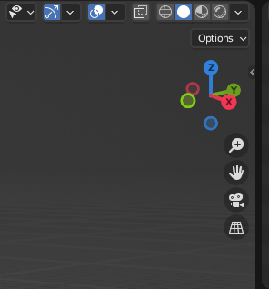
SIDEBAR NOT VISIBLE SIDEBAR CLEARLY VISIBLE

B. Download and Import a test file in STL format
1. I will be using the “V17_HEAD.stl” model from here
2. It is highly advised that you use the same model for testing and learning, it will need to be unzipped so don’t forget where you placed it
3. Import the model using the IMPORT STL button found in STEP 0: IMPORT in the HELMET section of the sidebar, if you import the model using the built-in Blender function, it will not work
4. Your screen should look something like this:
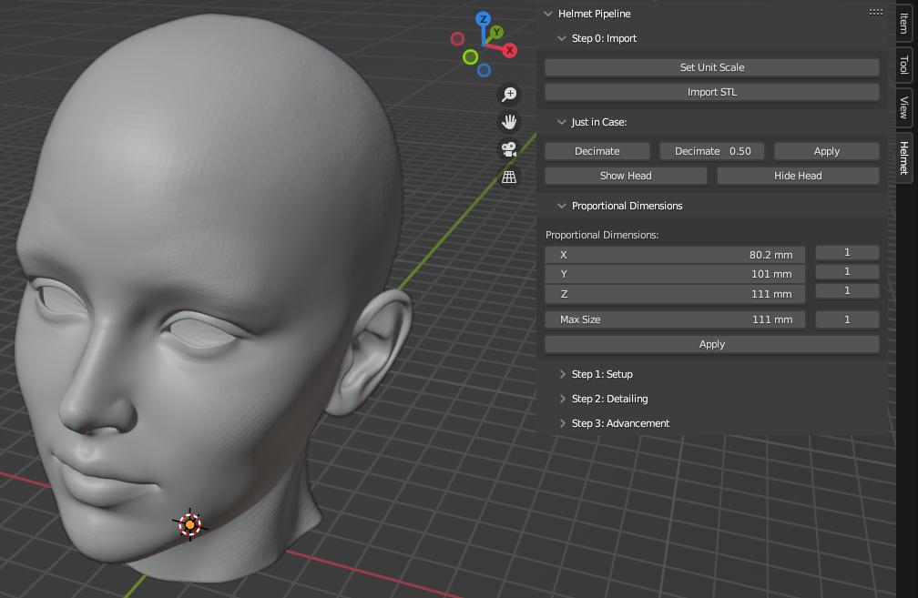
II. Blender Manipulation of Scan Data (CONTINUED)
C. PROPORTIONAL DIMENSIONS
1. Select the X row by left clicking, it should say 80.2mm or something very close to it.
2. Type “200” and hit ENTER.
3. The Y row should now read 251mm
4. The Z row should now read 276mm
5. EXTREMELY IMPORTANT:
a. Make certain to hit APPLY under the X, Y and Z rows.
b. Failure to do so will lead to all sorts of wonky behavior in Blender.
6. Your screen should look like this:
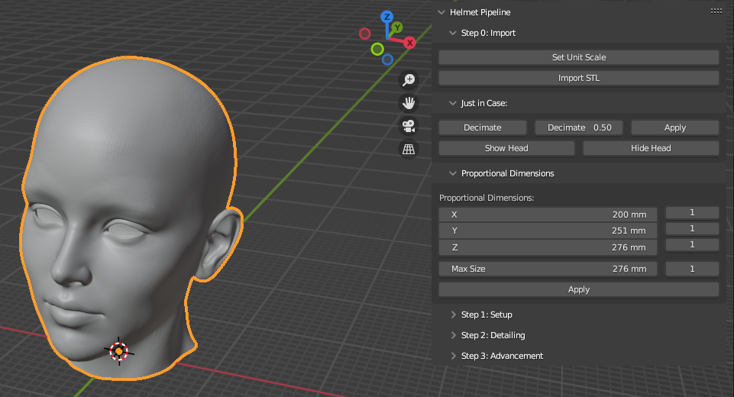
‘D. STEP 1: SETUP
1. Add Thickness
a. We are shooting for a standard helmet thickness of 0.25”, this is roughly 6.4mm and the add-on is setup to do this out of the box.
b. Click ADD THICKNESS and observe the changes to the model, then click APPLY
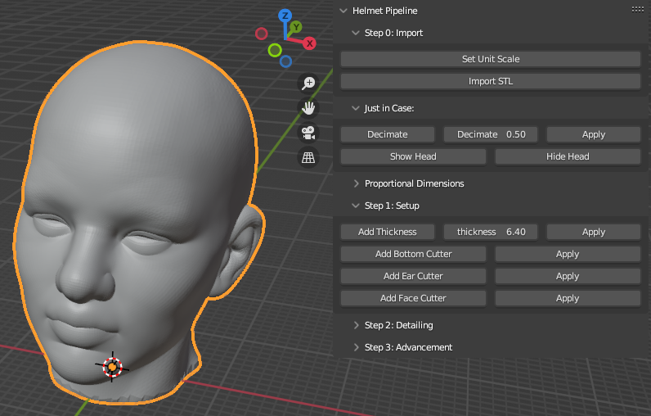

II. Blender Manipulation of Scan Data (CONTINUED)
D. STEP 1: SETUP (CONTINUED)
2. Add Bottom Cutter
a. Clicking the ADD BOTTOM CUTTER button should bring up a hollow cube that cuts off around half the face.
b. You can further manipulate the amount cut, either increasing or decreasing it by clicking the MOVE button on the far left side, as shown below:

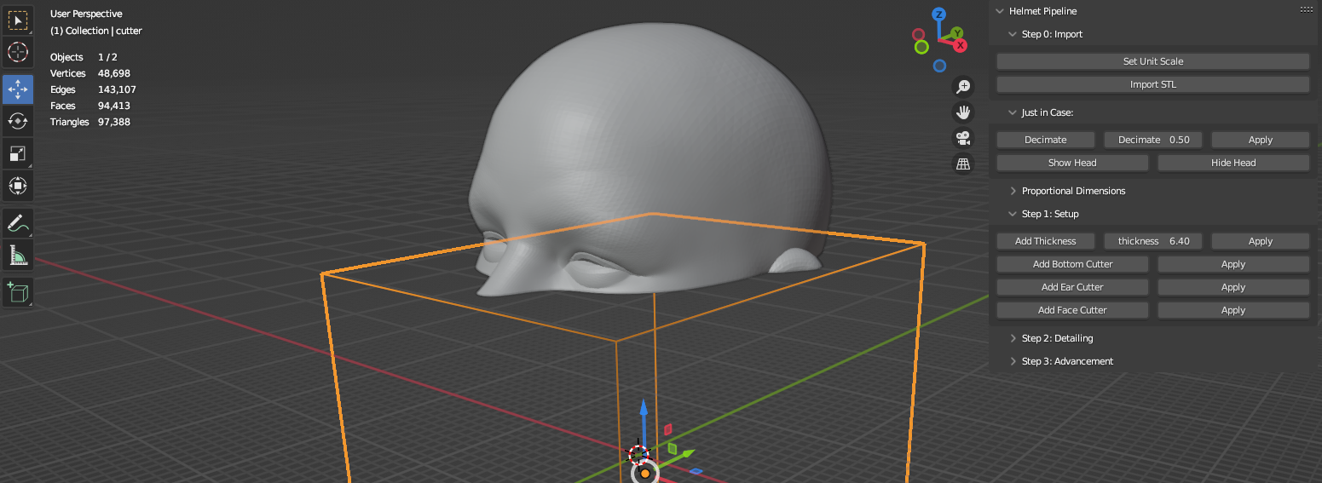
c. To move the cube hold left click on any of the arrows and drag it in the preferred direction.
d. A box entitled MOVE will appear in the lower left corner, click the Z ROW and change the value to -20.0mm. X and Y rows should stay at 0.
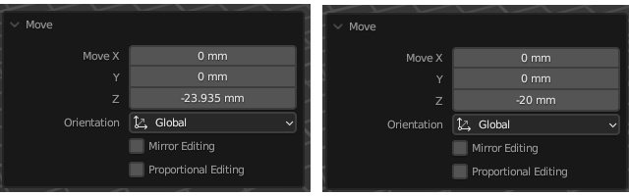

e. Click anywhere off the MOVE box to make it disappear, you should see something like this:
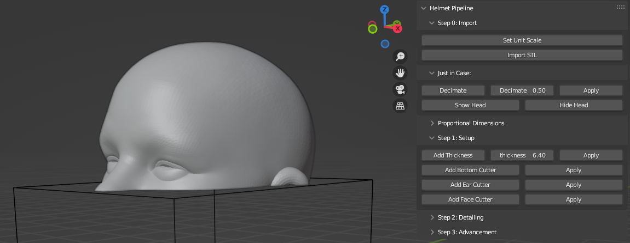
f. Click the APPLY button next to the ADD BOTTOM CUTTER button and wait
II. Blender Manipulation of Scan Data (CONTINUED)
D. STEP 1: SETUP (CONTINUED)
3. Add Ear Cutter
a. Click ADD EAR CUTTER button in the sidebar, then click the TRANSFORM button on the other side of the screen
b. Click SHOW HEAD in the JUST IN CASE section to get an idea of exactly where the ears are, this will help as you manipulate the TRANSFORM with the arrows and cubes. You should see something like this:
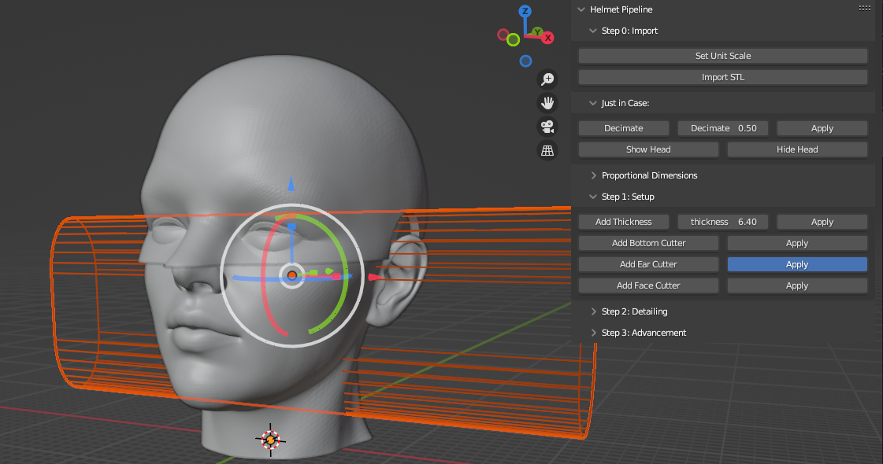
c. Click the APPLY button next to ADD EAR CUTTER and wait

4. Add Face Cutter
a. Click ADD FACE CUTTER button in the sidebar, you will see the following:
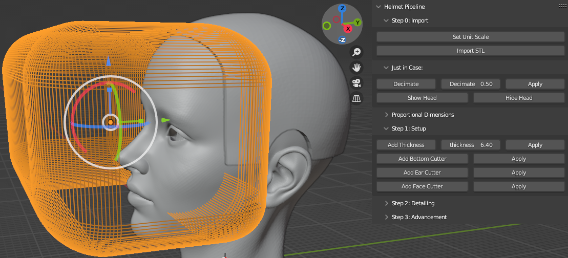
II. Blender Manipulation of Scan Data (CONTINUED)
D. STEP 1: SETUP (CONTINUED)
4. Add Face Cutter (CONTINUED)
b. Move the orange box around so that it just barely covers the edge of the forehead while overlapping and eliminating the eyes. Clicking SHOW HEAD helps a lot here.
c. Click APPLY next to ADD FACE CUTTER and wait.
d. You should have something like this:
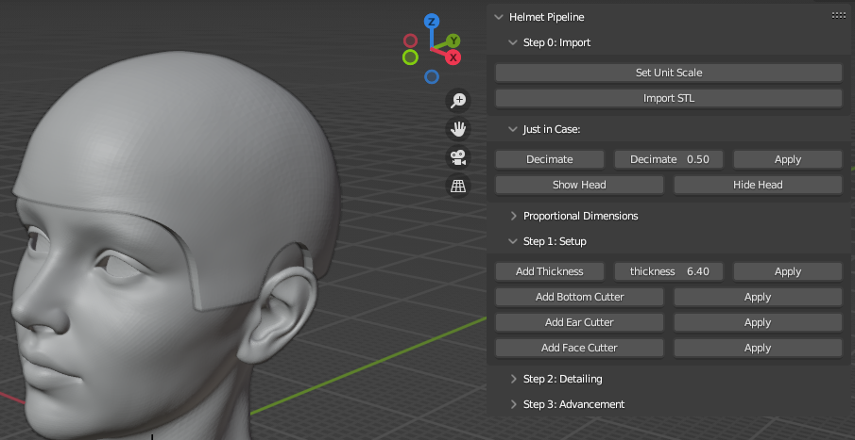

II. Blender Manipulation of Scan Data (CONTINUED)
E. STEP 2: DETAILING
1. Add Hinge
a. Click ADD HINGE, change the variables to be EXACTLY like the following and hit APPLY
b. You should see this, or something close to it:

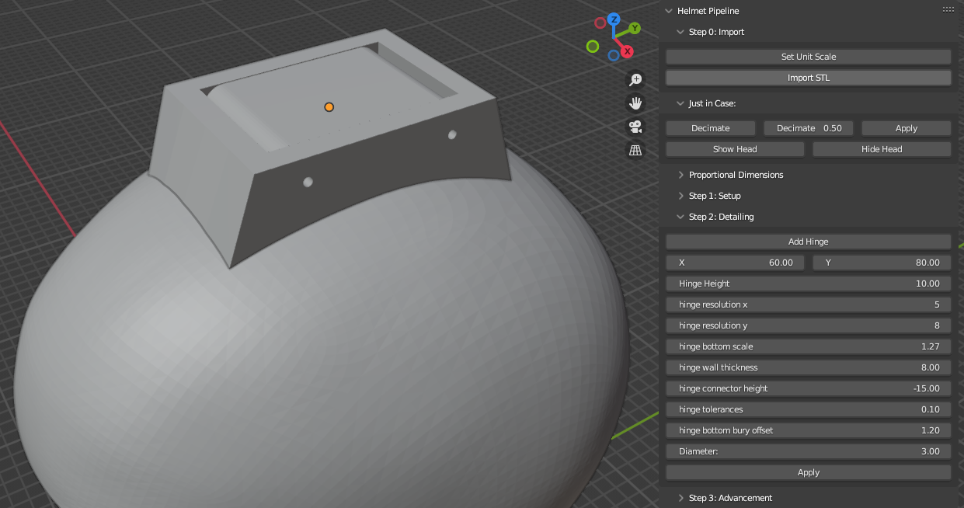
2. IMPORTANT NOTE:
a. If an object named HOLDER doesn’t appear in the column under SCENE COLLECTION, then you messed up
b. In this case you need to CTRL-Z or start over from the beginning

F. STEP 3: ADVANCEMENT
1. Cut Middle
a. Select the CUT MIDDLE button
b. You should see something like this, hit APPLY and wait:
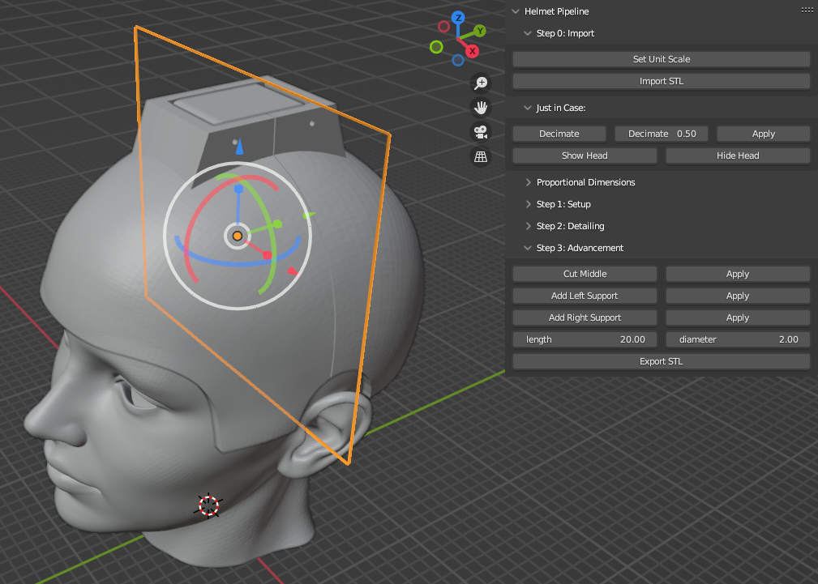
II. Blender Manipulation of Scan Data (CONTINUED)
F. STEP 3: ADVANCEMENT
2. Add Left and Right supports
a. Select ADD LEFT SUPPORT
b. Screen will shift, you MAY need to toggle XRAY or other VIEWPORT SHADING buttons in the upper right, move the pin to the middle of the helmet as best you can.
c. It should look like this, hit APPLY and then wait a bit.

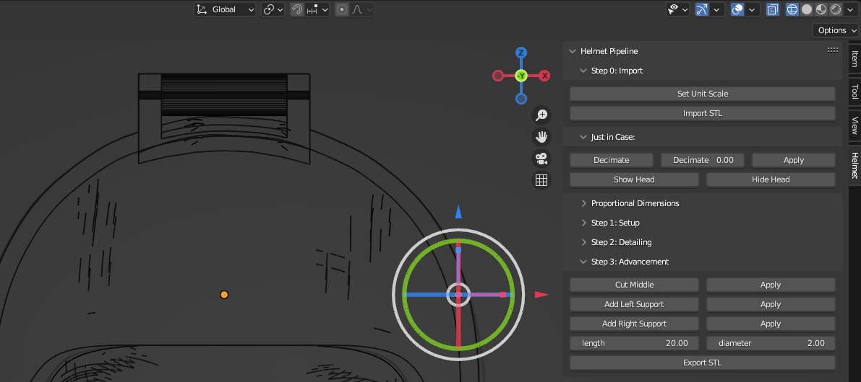

d. Repeat the above with the ADD RIGHT SUPPORT option

The final model should look something like this. Save 3 or 4 versions in .BLEND format and break them out
1 by 1 and send them to a CNC or 3D printer via the EXPORT > STL function. It’s not pretty but it works.
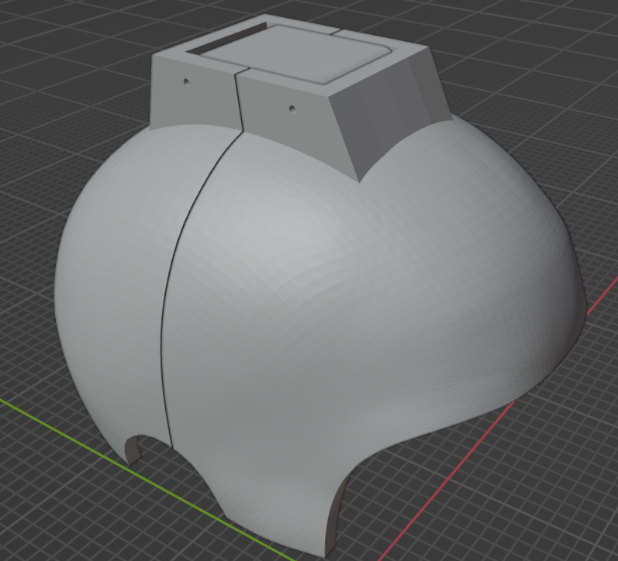
Alternatively you can use the EXPORT STL function and try it print all the parts at the same time but your mileage my vary.

